Use Lab 0 as a reference to this Lab
Click hyperlinks (blue underlined text) to learn more about a particular topic or concept.

Objectives
- Connect 7 LEDs & a pushbutton to the breadboard
- Create a traffic light system

Parts/Equipment Required

- Arduino Uno
- Breadboard
- Laptop
- USB Cable
- Several LEDs
- Several 470Ω Resistors
- Pushbutton
- Various Wires

Traffic Light Graphic

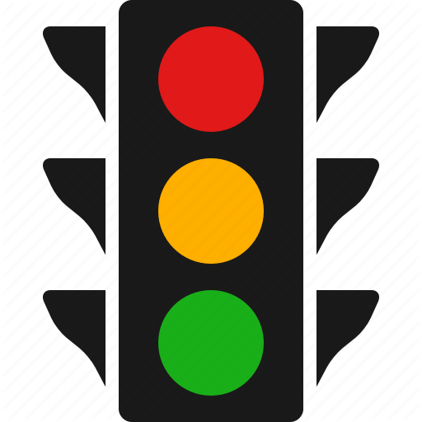
Using a Blue LED to represent the Walking Light, being activated by a push-button. The Walk Light will blink for the desired time and return back to the normal functionality after.
We will be mimicking a Traffic Light for this Lab. Using 2 sets of Red, Yellow and Green LED’s to represent the symbol colours of a set of Traffic Lights.

Hardware
In this lab, we are going to be wiring a circuit that looks like this:

- For this lab, it would be a good idea to start with a fresh, blank breadboard.

- Start by adding two red, two yellow, two green, and one blue LED to the breadboard in this pattern.

Remember that the blue LED may look clear and not blue.

- Now add 470Ω resistors for each LED. Make sure to add them to the anode of the LED.

- Now connect a switch in the space provided in the middle of the board.

- A 470Ω resistor should be added to pull-up the button.

- All of the cathodes on the LEDs and one side of the switch can be connected to ground on the Arduino.

- The 470 Ω resistor on the Arduino can be connected to +5V.

The side of the switch with the resistor can be connected to pin 2 on the Arduino.

- Now all the LEDs can be connected to the Arduino. Depending on what pins you connect the LEDs to you may have to modify the code.

Software
Type the code on the next page into the Arduino IDE. Because there is a lot of code, it might be a good idea to copy and paste it from https://arudino.zaugg.ca /code/Lab4_Code.html instead. Once you’ve copied the code, flashed the Arduino, and verified that things are working correctly, feel free to mess around with different parts of the code to see what they do. There are a lot of interesting and advanced components to this code.

