Use Lab 0 as a reference to this Lab
Click hyperlinks (blue underlined text) to learn more about a particular topic or concept.

Objectives
- Connect 7 LEDs in a sequence
- Control the sequence with a Pushbutton

Parts/Equipment Required

- Arduino Uno
- Breadboard
- Laptop
- USB Cable
- Several LEDs
- Several 470Ω Resistors
- Pushbutton
- Various Wires

Harware
In this lab, we are going to be wiring a circuit that looks like this:

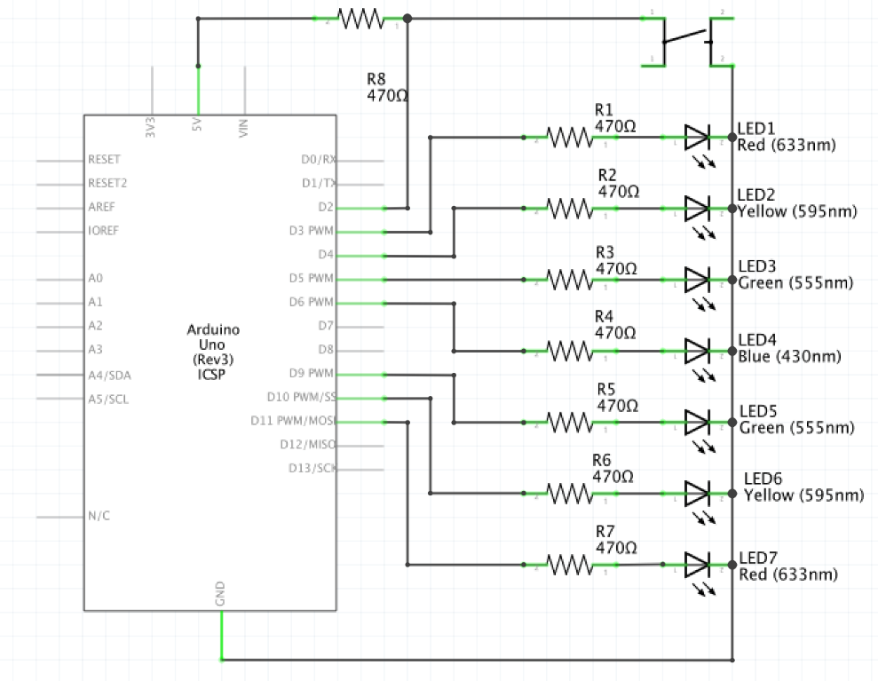
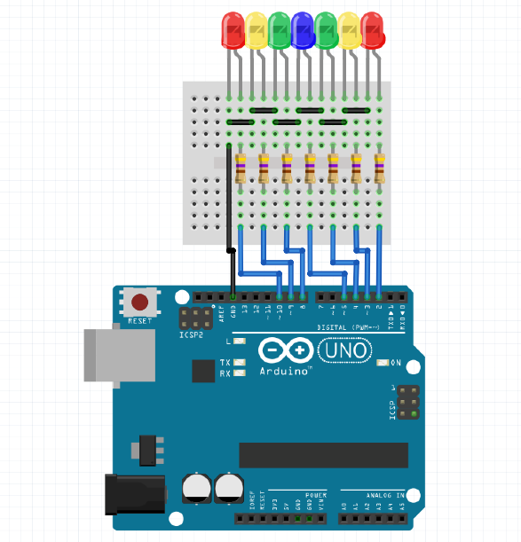
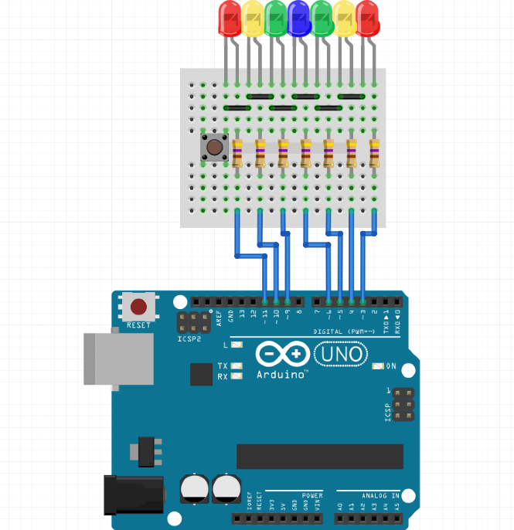
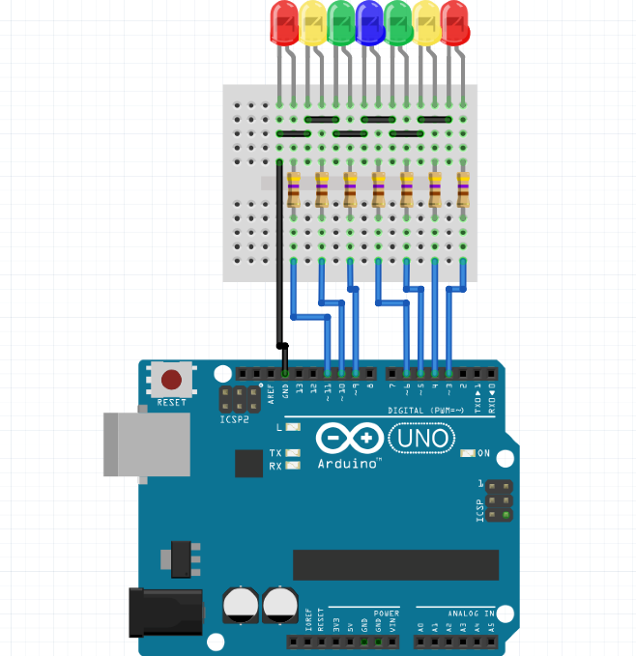
- Remove the Ground Wire, and insert the pushbutton, connecting with the last LED on the left.
- Now change the pins to 3,4,5,6 & 9,10,11 to make room for the pushbutton.
- This lab is an extension on Lab 2, using the ending product.

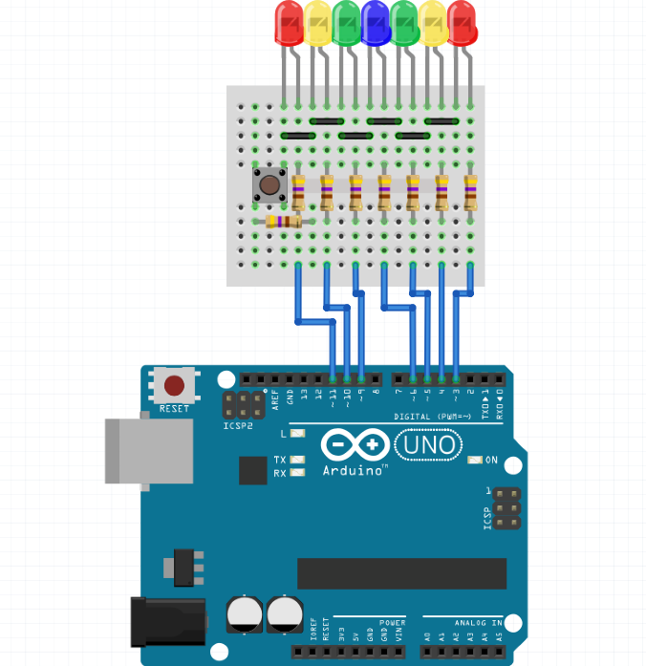

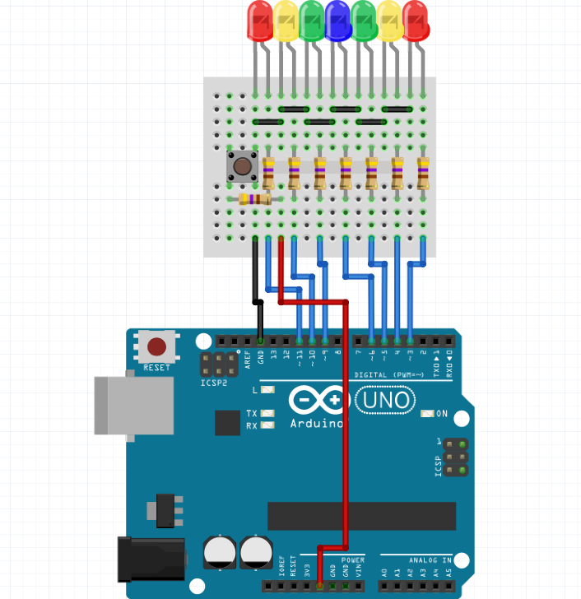
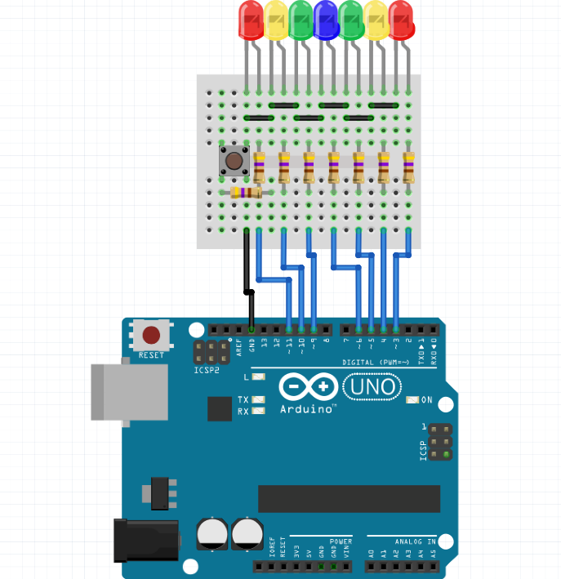
- Connect the 5V power supply the end of the 470Ω resistor connected to the pushbutton.
- Add a new black ground wire to the right side of the pushbutton.
- Add a 470Ω resistor from the pushbutton to a part of the Breadboard with no wire.
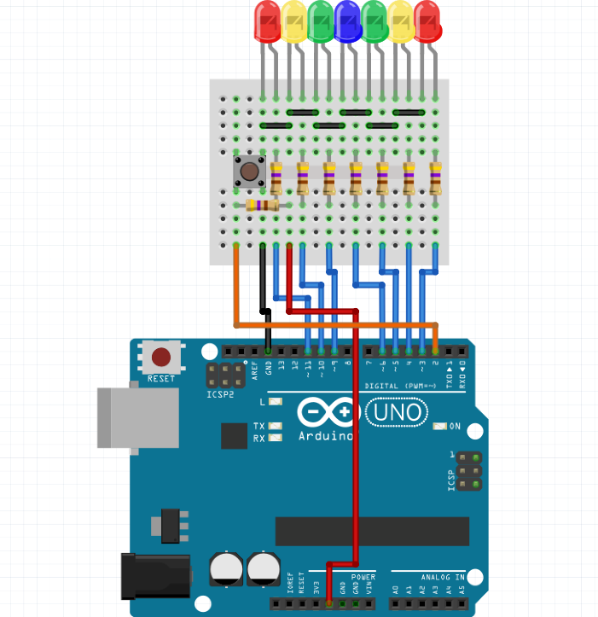

- Connect Pin 2 of the Arduino to the left side of the pushbutton with a different coloured wire. Must be in Pin 2 for the Pushbutton.

Software
Type the code on the next page into the Arduino IDE. Because there is a lot of code, it might be a good idea to copy and paste it from https://arudino.zaugg.ca /code/Lab3_Code.html instead. Once you’ve copied the code, flashed the Arduino, and verified that things are working correctly, feel free to mess around with different parts of the code to see what they do. There are a lot of interesting and advanced components to this code.
