Use Lab 0 as a reference to this Lab
Click hyperlinks (blue underlined text) to learn more about a particular topic or concept.

Objectives
- Connect more than 1 LED to the breadboard
- Control each LED in a sequence

Parts/Equipment Required

- Arduino Uno
- Breadboard
- Laptop
- USB Cable
- Several LEDs
- Several 470Ω Resistors
- Various Wires

Hardware

- Place an LED on the breadboard beside the LED from the first lab.

- Use a short wire to connect the LED cathodes together

3. Connect the anode to a 470Ω resistor
- Connect the other side of the 470Ω resistor to pin 3 on the Ardiuno.

- Repeat these steps as many times as you’d like for as many LEDs as you’d like. Make sure to use different pins on the Arduino. (Modification to the code is necessary)

You do not have to wire the LED’s in a straight line or use the example colours.

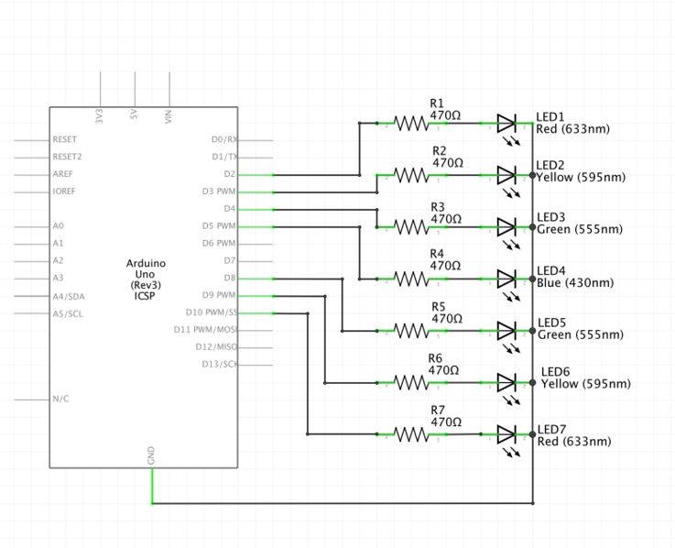

Software
Write down this code into the Arduino IDE. If you have wired your lab correctly this should control the first two LEDs. You’ll have to modify the code yourself to get subsequent LEDs to turn on.
Feel free to experiment with creating different sequences by moving/modifying the digitalWrite and delay functions.
Don’t forget to upload the code.
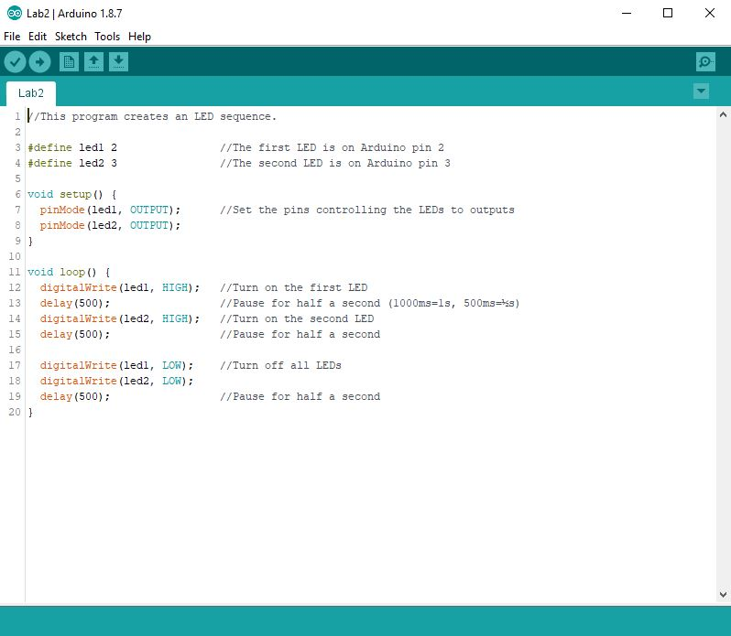
http://arduino.zaugg.ca/code/Lab2_Code.html

What is setup() and loop()?
You’ve probably noticed in lab 1 and 2 that there have been blocks of code separated into two sections, the first one being setup(), and the second one being loop(). These are what’s called functions, and all the code within the body of the function (between { and } ) are ran by the Arduino whenever the function is called.
Calling a function is what happens whenever there is a command with brackets but no curly brackets. pinMode() is a function, its body has been written for us by the programmers of the Arduino IDE so we don’t have to worry about it ourselves. digitalWrite() is also a function, and so is delay(). In the case of all these functions, they take in information such as the amount of time to delay, which pins to control, and what to do with those pins (set them high, low, input, or output). That is what’s called a parameter. Setup() and loop() have no parameters, thus why their brackets have nothing in them.
Like the body of the pinMode(), digitalWrite(), and delay() functions, the code that calls the setup() and loop() functions have been written for us. Setup() is called when the Arduino is first powered on, and is only ran once. Loop() is called once setup() has finished, and will keep on running over and over until the Arduino loses power.

