Use Pages 1 & 2 as a reference to the Lab. It will become very helpful for learning the fundamentals before executing Lab 1. Use Pages 3 & 4 to download the software for the following Labs.

Components
Click any photo to learn more about the component!

Breadboard
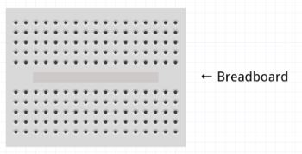
- Wires, Resistors, and LED’s are place in the holes, interconnected with the holes below/above.

- Split into two parts, not connected to one another.
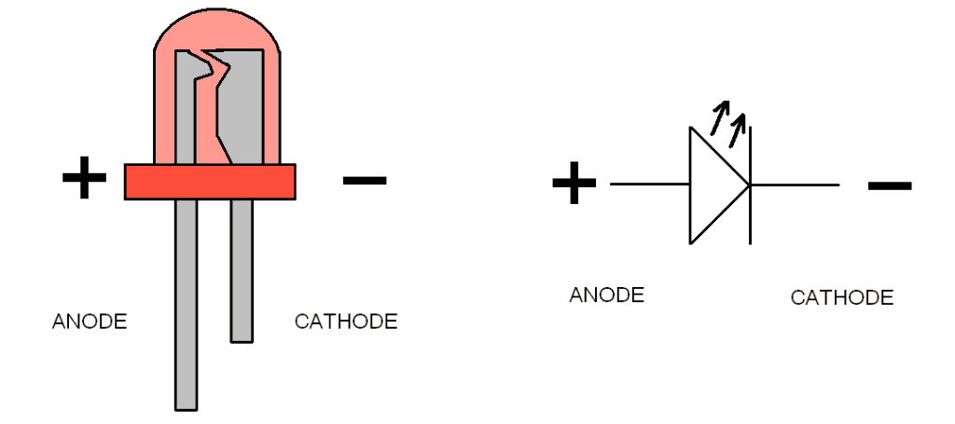

LEDs
LED On
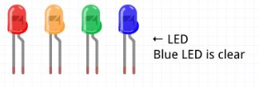
- The longer wire is the Anode and shorter is Cathode

- Power will be going through the long wire first to illuminate the LED.

Resistors
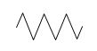
Resistors are able to be placed in either direction.
Resistor Symbol

- Colour coordinated to display
100Ω - (Brown, Black, Brown, Gold)
the resistive value.
470Ω - (Yellow, Violet, Brown, Gold)
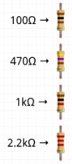
- Used to create current and
protect other components.
1kΩ - (Brown, Black, Red, Gold)
2.2kΩ - (Red, Red, Red, Gold)

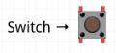
Switches
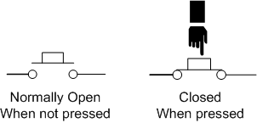
- The switch is not allowing any power through
when it is not pressed.

- When pressed down, it allows for power to go
through.

Arduino-Uno
Connected Wires
Ground

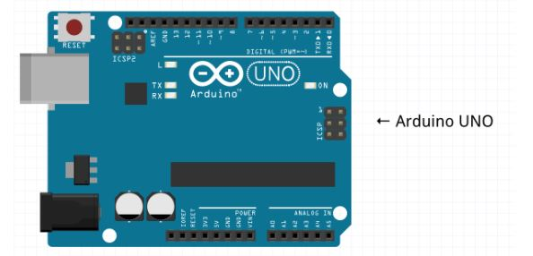
Connect to Computer
Connect to Power after Programmed

Ground

Schematic Example:
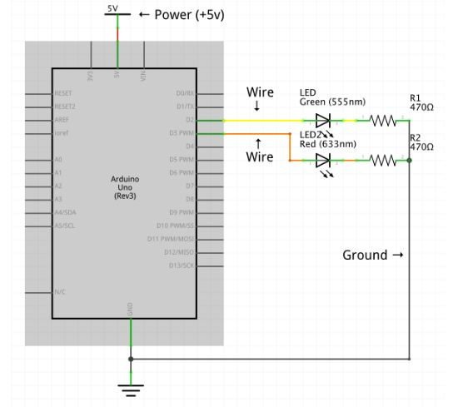
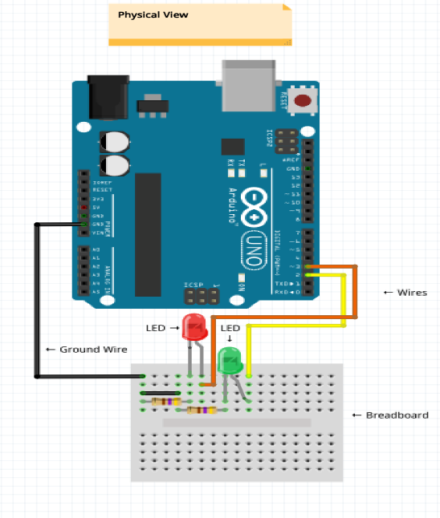

Arduino Software

Windows Install Instructions
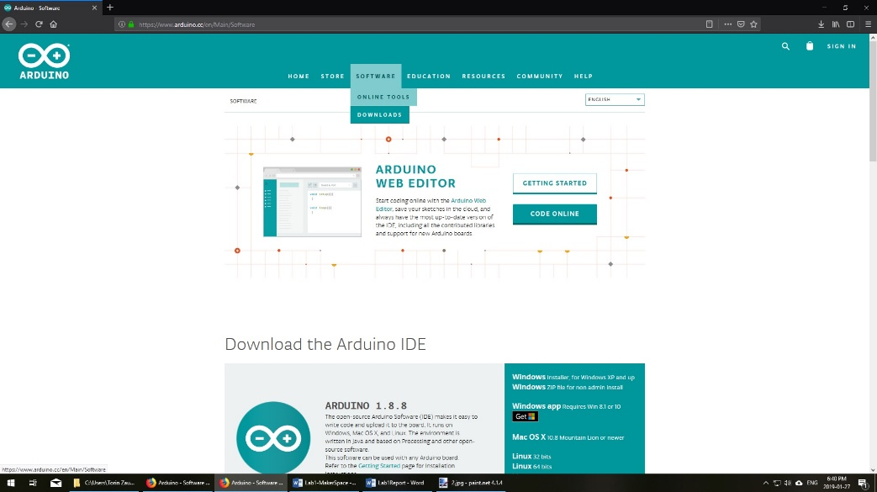
If your laptop or computer is running Windows:
- In your web browser, go to www.arduino.cc
- Under the software tab, click downloads
- Click “windows installer”
- Click “Just Download”
- If necessary, click “save file”
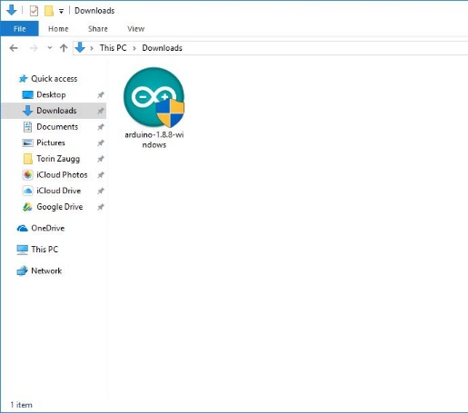
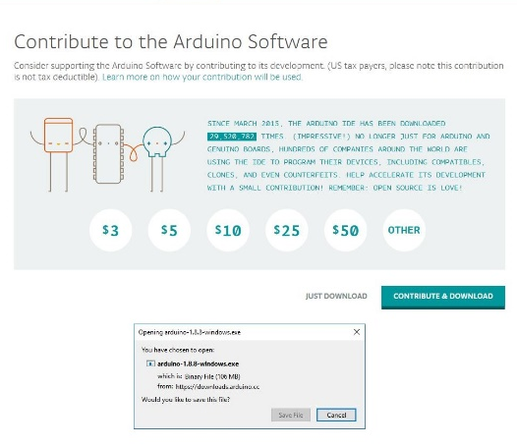
- Once the file has finished downloading, navigate to your downloads folder and double click “Arduino-1.8.8-windows.exe”.
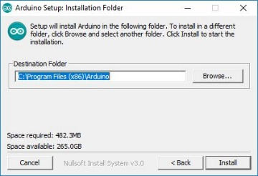
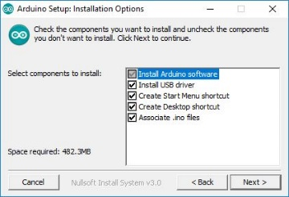
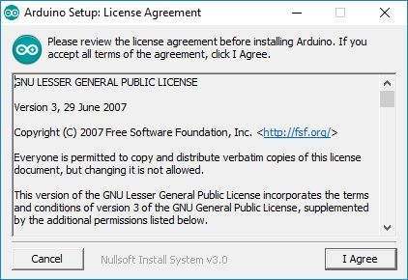
- A warning may appear asking if you want “this app to make changes to your device”. Click yes.
- Click your way through the installer. Three times in the install process a window will open asking “would you like to install this device software”. Always click Install.
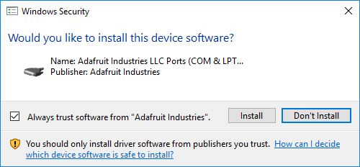
- Once the software is finished installing, go to the start menu and find “Arduino”.
- The first time you launch the software it’s going to ask if you want to let it through the firewall. Click Allow Access.
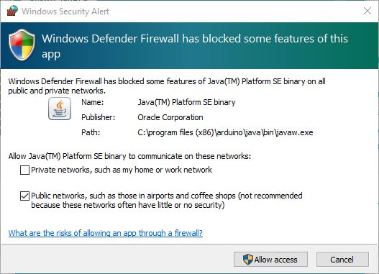
- The Arduino software is installed, you’re ready for your first Arduino program!

MacOS Install Instructions
If your laptop or computer is running MacOS:
- In your web browser, go to www.arduino.cc
- Under the software tab, click downloads
- Click “Mac OS X”.
- Click “Just download”
- Once the file has finished downloading, navigate to the downloads folder and move Arduino.app to the applications folder.
- Navigate to the applications folder and launch Arduino. The first time you start it a window will open asking if you really want to open. Click “Open”.
- The Arduino software is installed, you’re ready for your first Arduino program!

